==============================================================================
COMMAND:
// program with for loop

import java.util.*;
class forloop_multiplication
{
public static void main(String args[])
{
Scanner sc=new Scanner(System.in);
System.out.println("Enter the Number");
int a=sc.nextInt();
int i;
for(i=1;i<11;i++)
{
System.out.println(a+" * "+i+" = "+a*i);
}
}
}

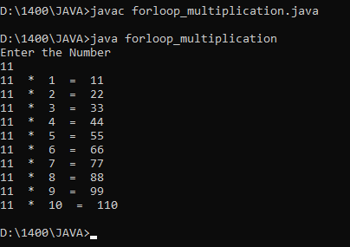
OUTPUT:

COMMAND:
// program to print welcome message

class area
{
public static void main(String args[])
{
double pi=3.14;
int r=5;
double area, perimeter;
area=pi*r*r;
perimeter=2*pi*r;
System.out.println("The area of Circle with radius"+r+"will be"+area);
System.out.println("The Perimeter of Circle with radius"+r+"will be"+perimeter);
}
}
OUTPUT:
